Monitor, Ports & Cables — Complete Practical Guide (Beginner → Advanced)
This explanation is hardware-accurate, exam-ready, and real-world useful.

🖥️ Monitor Basics (What Actually Matters)
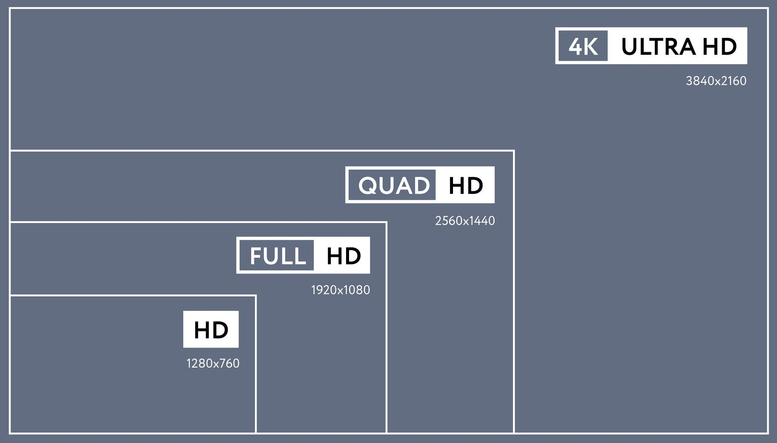
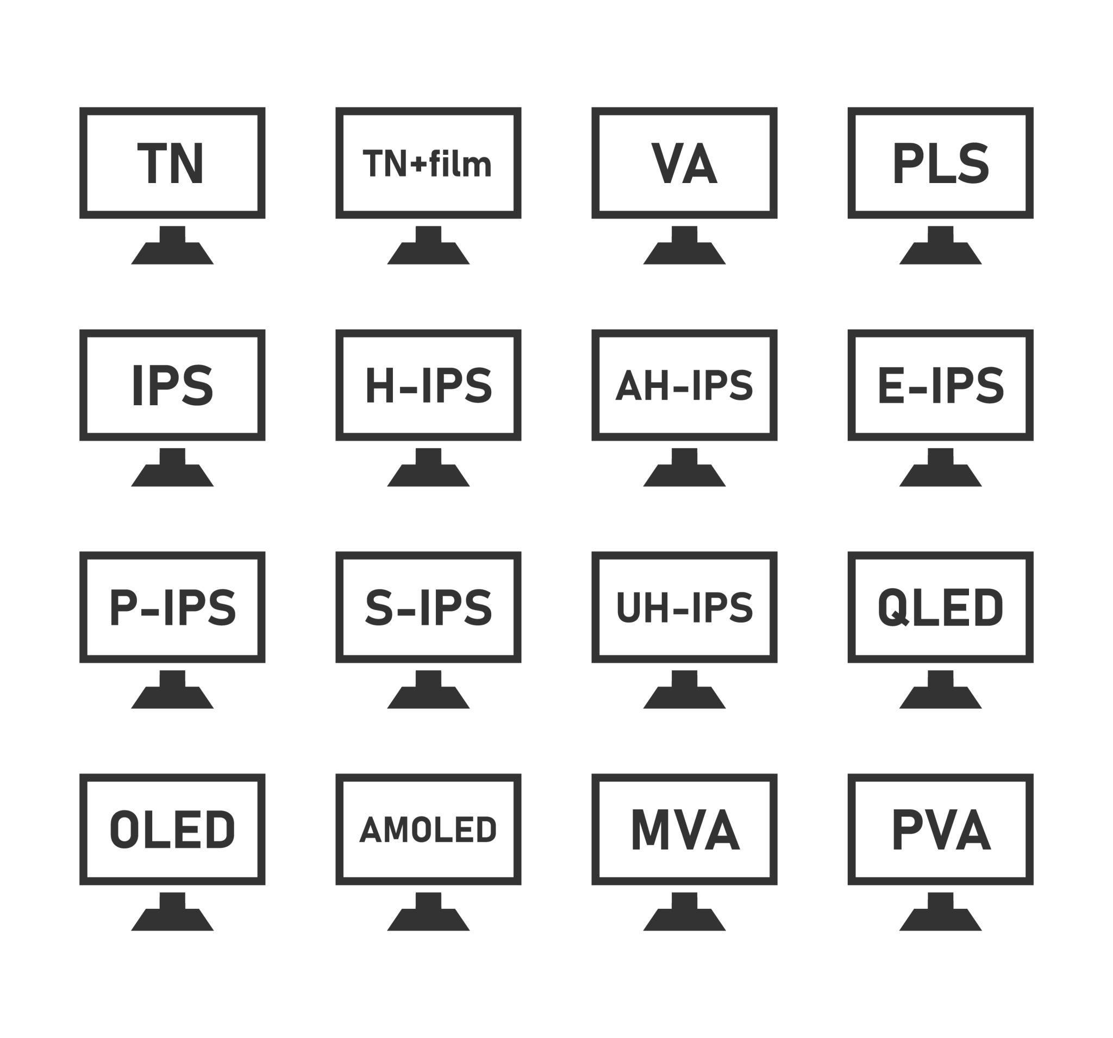
📏 Size (inches)
- Measured diagonally (24″, 27″, 32″)
- Bigger ≠ better always
Best picks
- 24″ → 1080p
- 27″ → 1440p
- 32″ → 4K

🖼️ Resolution (Sharpness)
Resolution = number of pixels
Resolution | Name
1920×1080 | Full HD
2560×1440 | 2K
3840×2160 | 4K
Higher resolution:
- Sharper image
- Needs stronger GPU

🔄 Refresh Rate (Smoothness)
Measured in Hz
Hz | Usage
60 Hz | Office
75 Hz | Casual
144 Hz | Gaming
240 Hz | Esports
⚠️ GPU + cable + monitor must all support the refresh rate.

🎨 Panel Types
Panel | Strength
IPS | Best colors, viewing angles
VA | Best contrast
TN | Fastest, poor colors

🔌 Display Cables (VERY IMPORTANT)
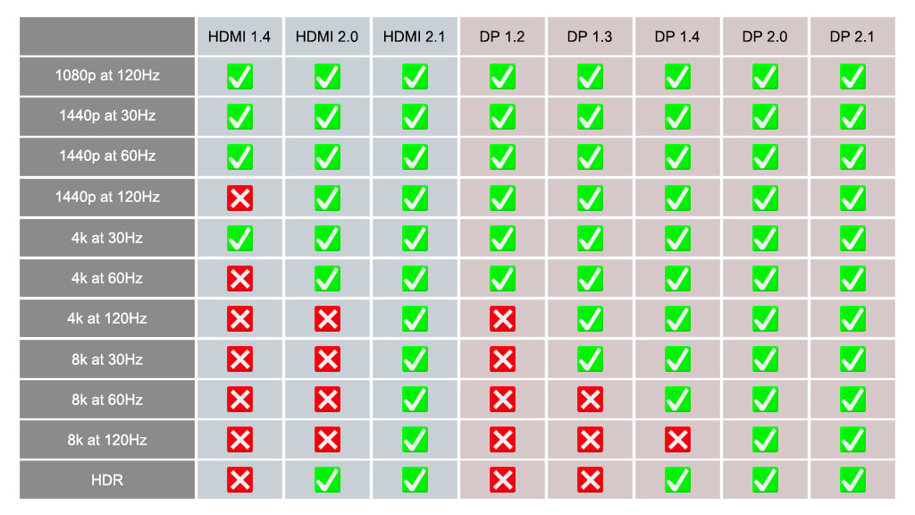
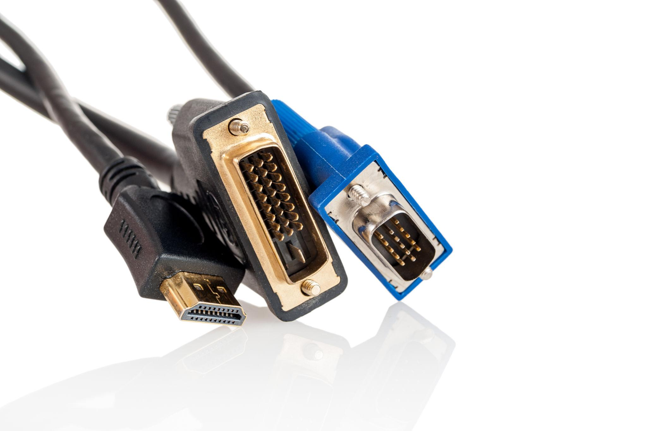
HDMI (High-Definition Multimedia Interface)
- Used in TVs, monitors, laptops
- Carries video + audio
HDMI Version | Max Capability
HDMI 1.4 | 1080p 144Hz
HDMI 2.0 | 1440p 144Hz
HDMI 2.1 | 4K 144Hz / 8K
✅ Easy
❌ Limited for high refresh gaming (older HDMI)

DisplayPort (DP)
- Designed for PCs
- Best for high refresh & high resolution
DP Version | Capability
DP 1.2 | 1440p 144Hz
DP 1.4 | 4K 144Hz
DP 2.0 | 8K / extreme bandwidth
✅ Best for gaming & professional work
✅ Supports G-Sync / FreeSync better

VGA (OLD – Avoid)
- Analog signal
- Blurry image
- No audio
❌ Legacy only

DVI (OLD)
- Digital (better than VGA)
- No audio
- Limited refresh
❌ Obsolete

🧠 HDMI vs DisplayPort (Simple Rule)
TV / casual use → HDMI
Gaming / high refresh → DisplayPort

🔌 USB Ports Explained (BIG CONFUSION AREA)
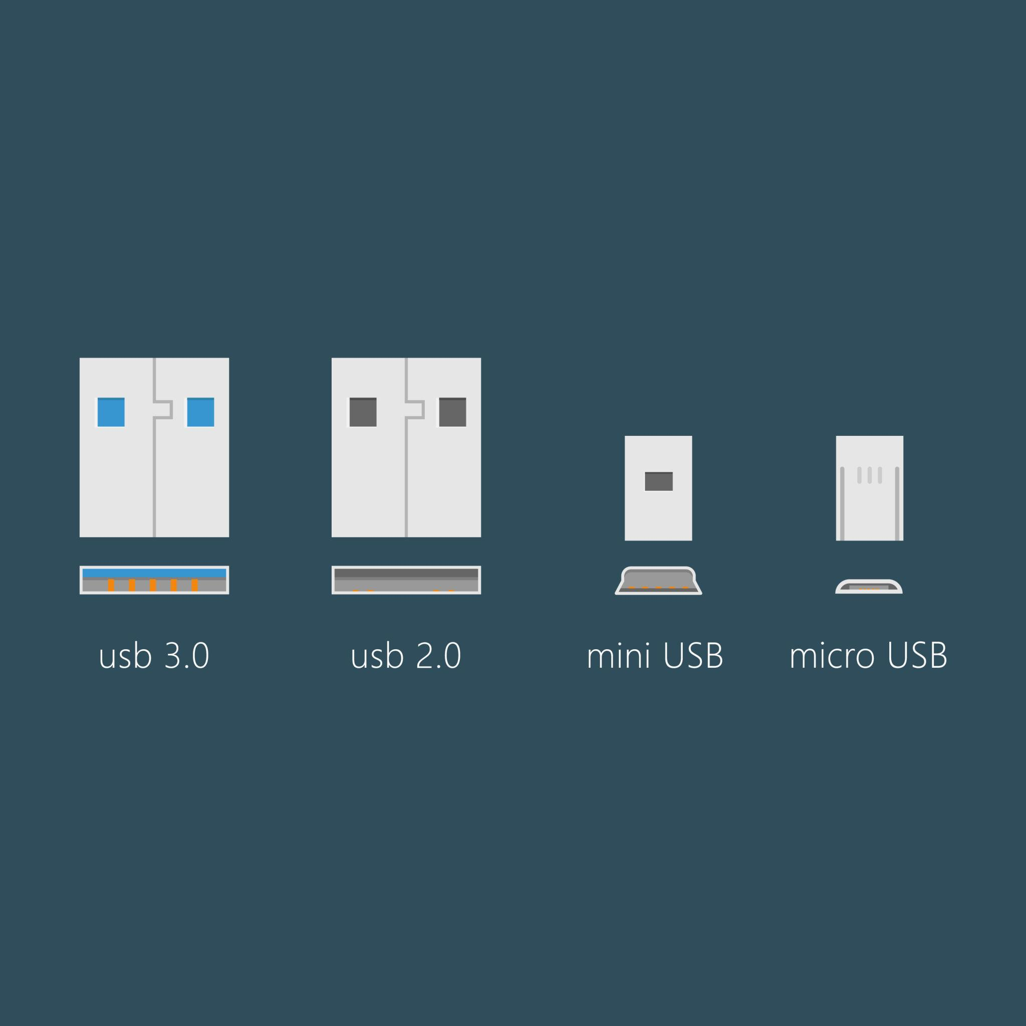
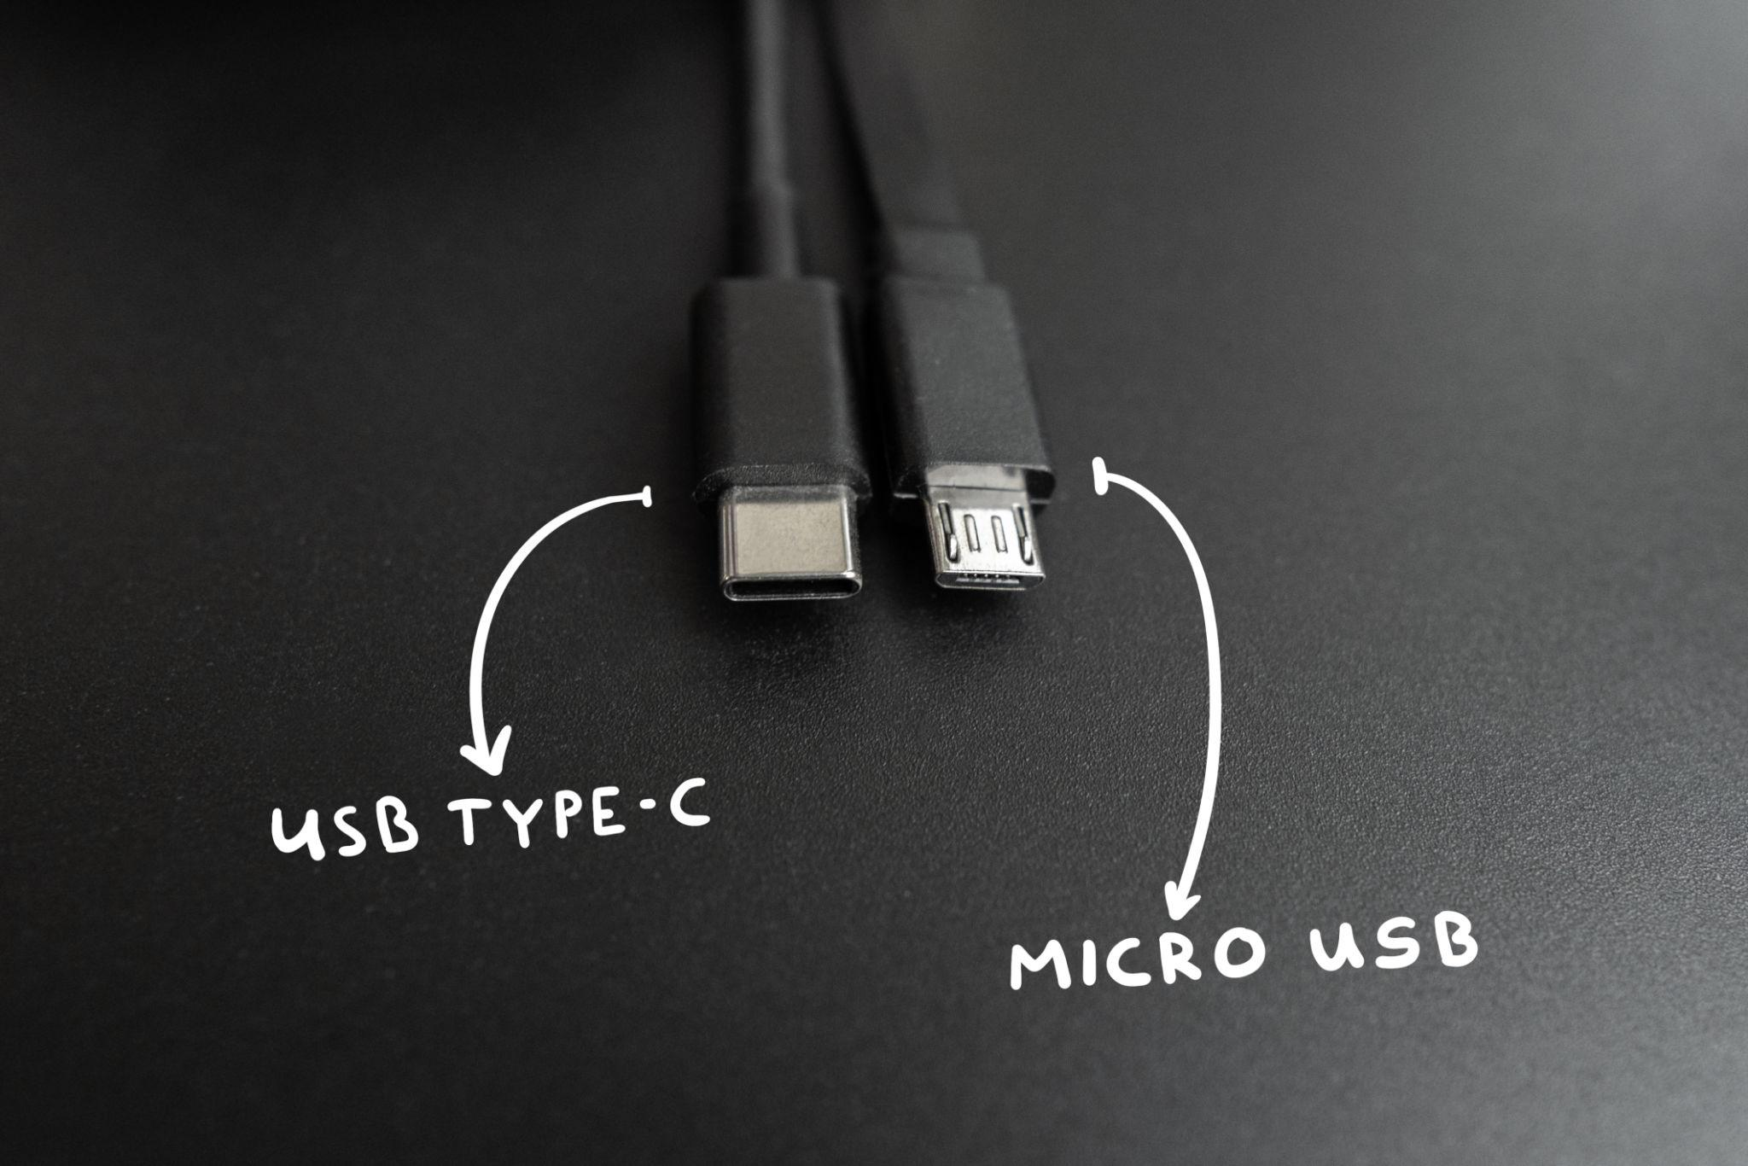
⚠️ USB Version ≠ USB Shape
USB Versions (Speed)
USB Version | Speed
USB 2.0 | 480 Mbps
USB 3.2 Gen1 | 5 Gbps
USB 3.2 Gen2 | 10 Gbps
USB 3.2 Gen2x2 | 20 Gbps

USB Shapes
Shape | Meaning
USB-A | Traditional rectangle
USB-C | Reversible, modern
Micro-USB | Old phones
Mini-USB | Cameras
📌 USB-C does NOT mean fast automatically

USB-C (Truth)
USB-C is only a connector shape
It may support:
- Charging
- Data
- Display (DisplayPort Alt Mode)
OR may support only charging
⚠️ Always check specifications.

⚡ Thunderbolt (Very Powerful)
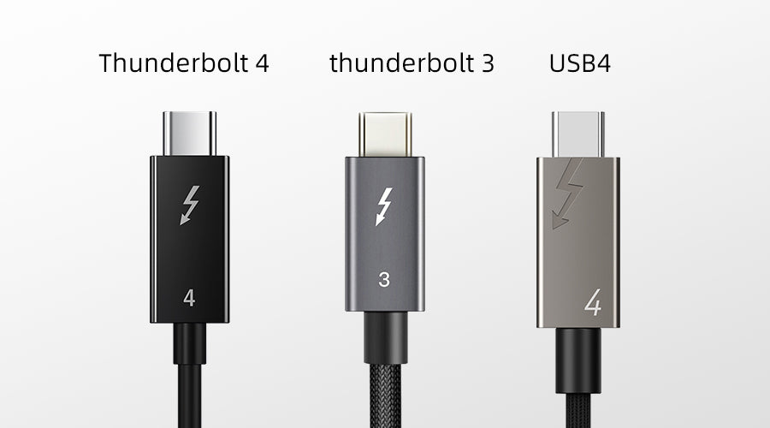
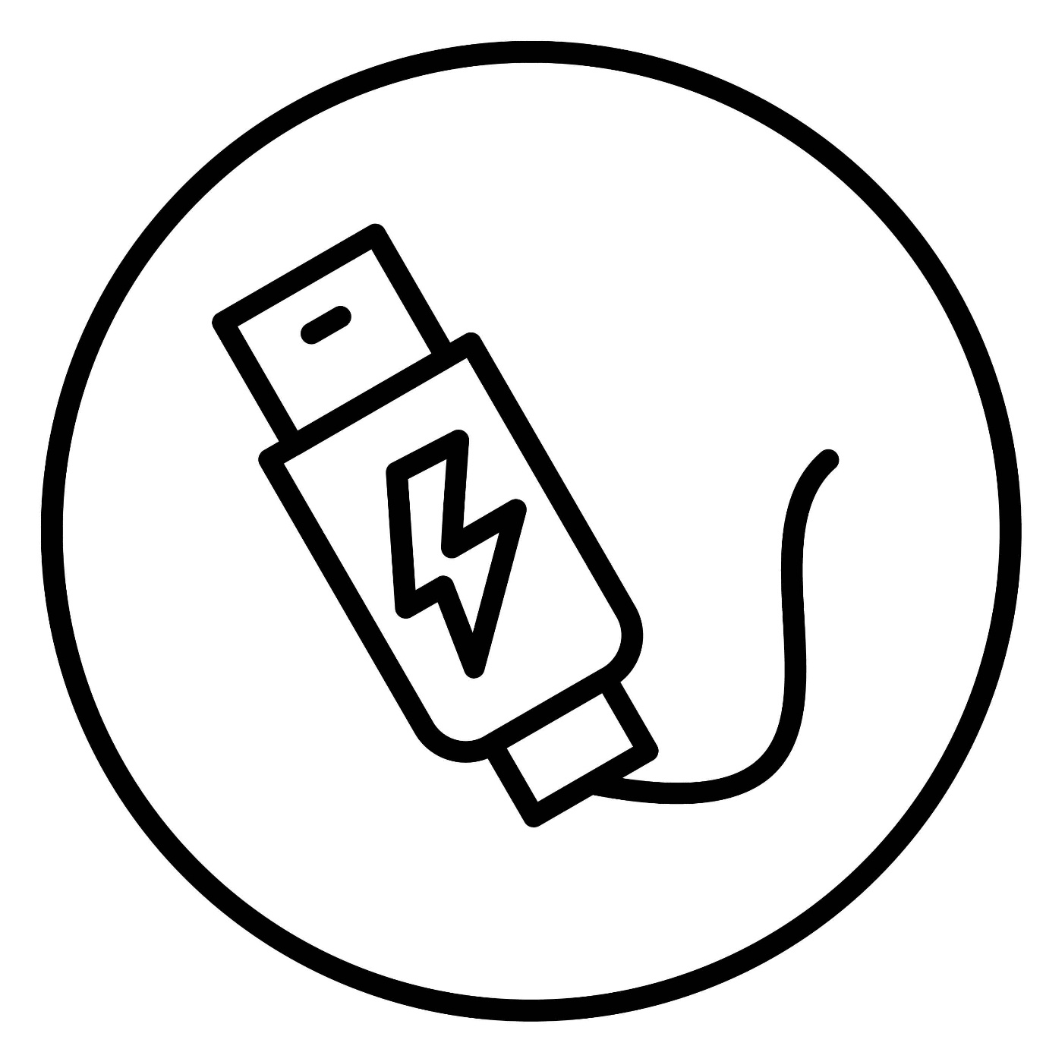
Thunderbolt 3 / 4
Uses USB-C connector but much more capable
What it can do:
- 40 Gbps speed
- External GPUs (eGPU)
- 4K / 8K displays
- Docking stations
- Data + power + display in one cable
Feature | Thunderbolt
Speed | 40 Gbps
Display | Yes
Power | Yes
Daisy chaining | Yes
⚠️ Needs:
- Thunderbolt port
- Thunderbolt-certified cable

🌐 LAN / Ethernet Cable
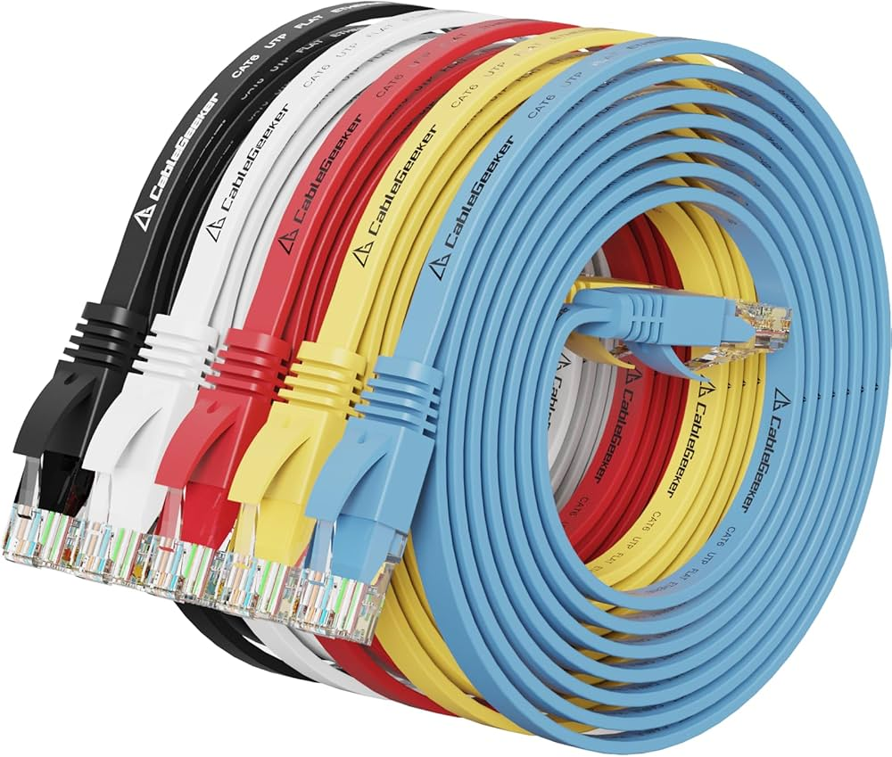
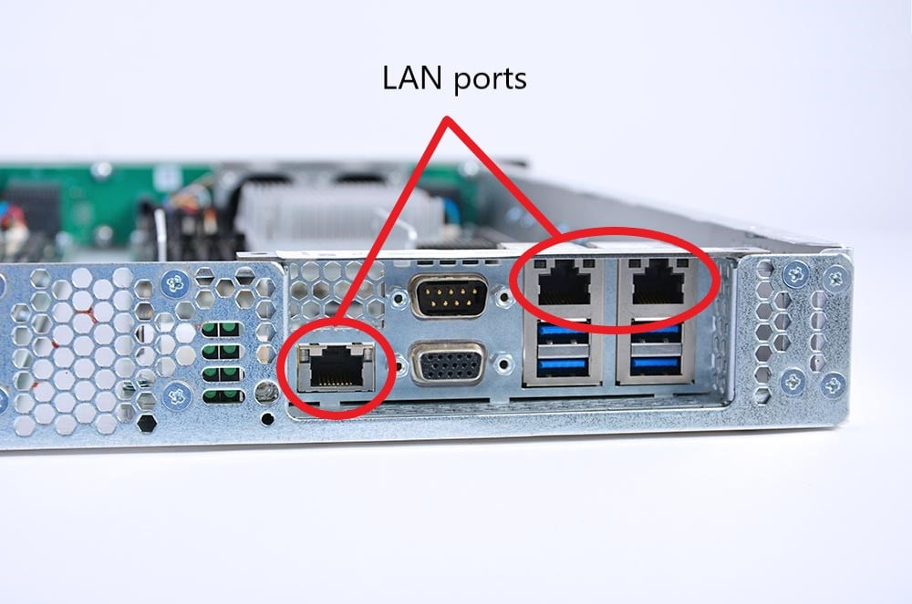
Ethernet (RJ45)
- Wired internet
- Lower latency than Wi-Fi
- Stable & fast
Cable | Speed
Cat5e | 1 Gbps
Cat6 | 10 Gbps (short)
Cat6a | 10 Gbps
Best for:
- Gaming
- Servers
- Workstations
- AI data transfer

🔊 Audio Ports
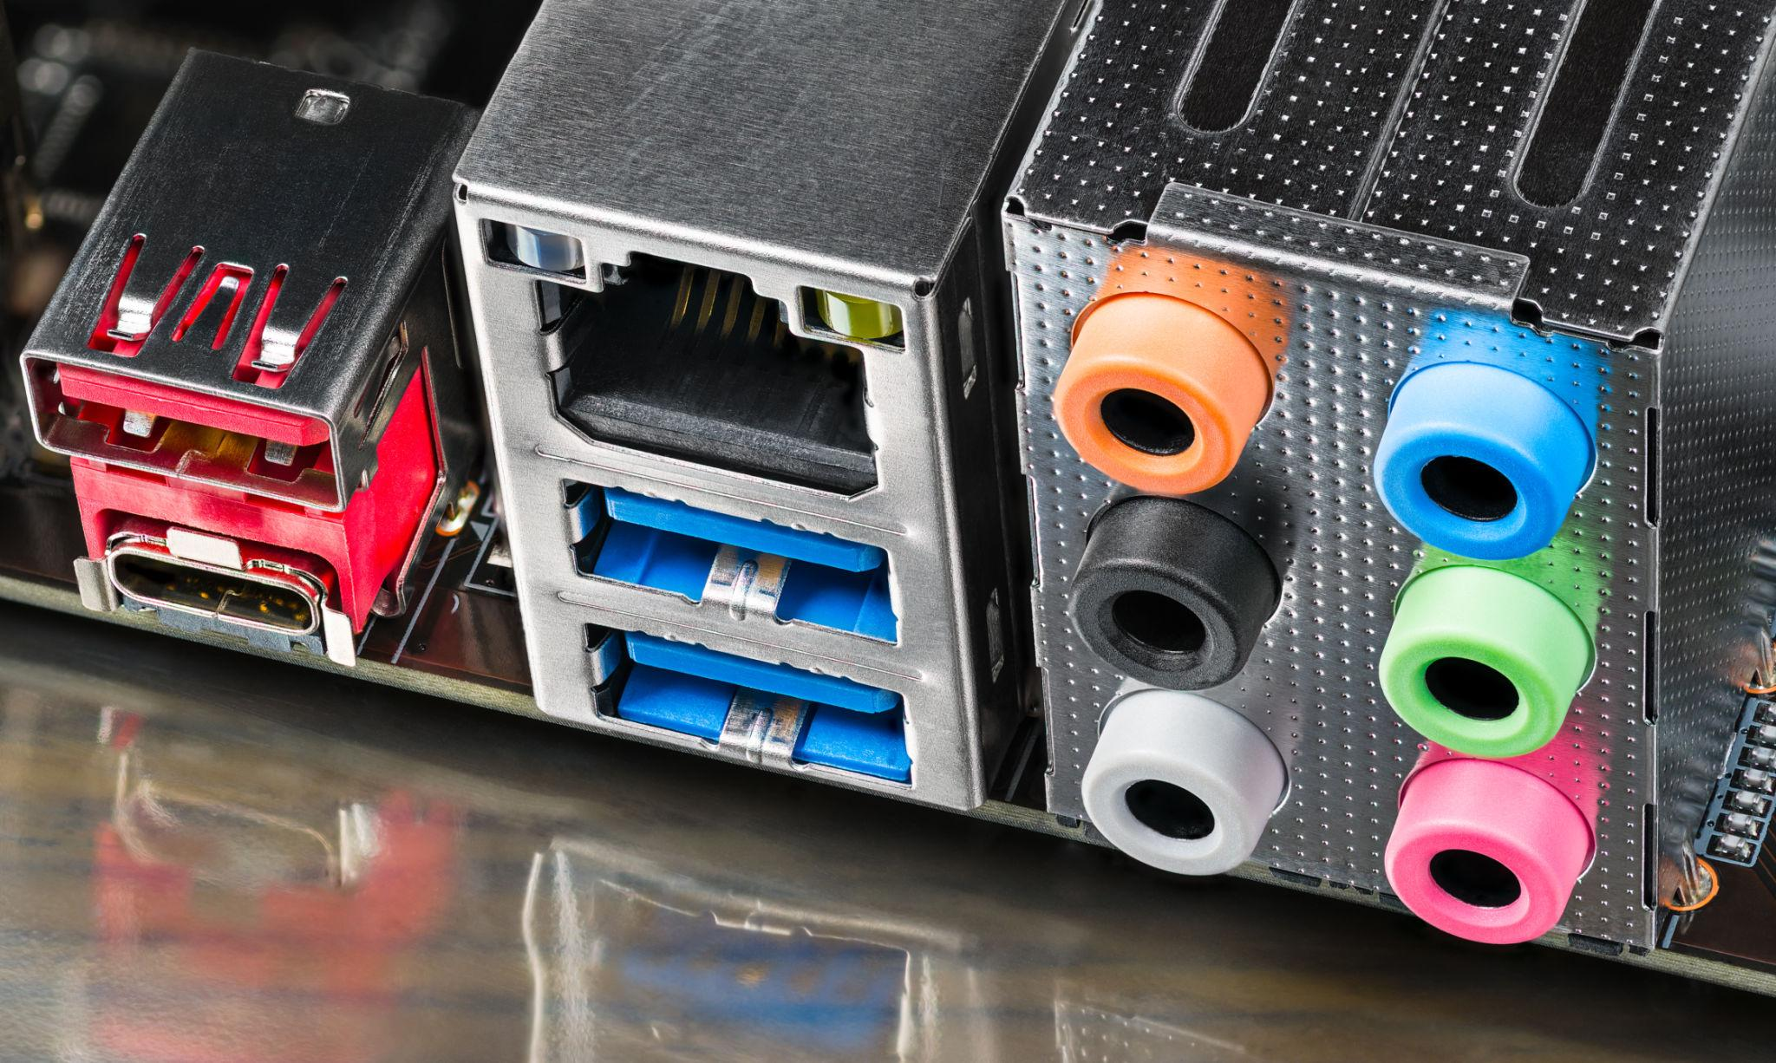
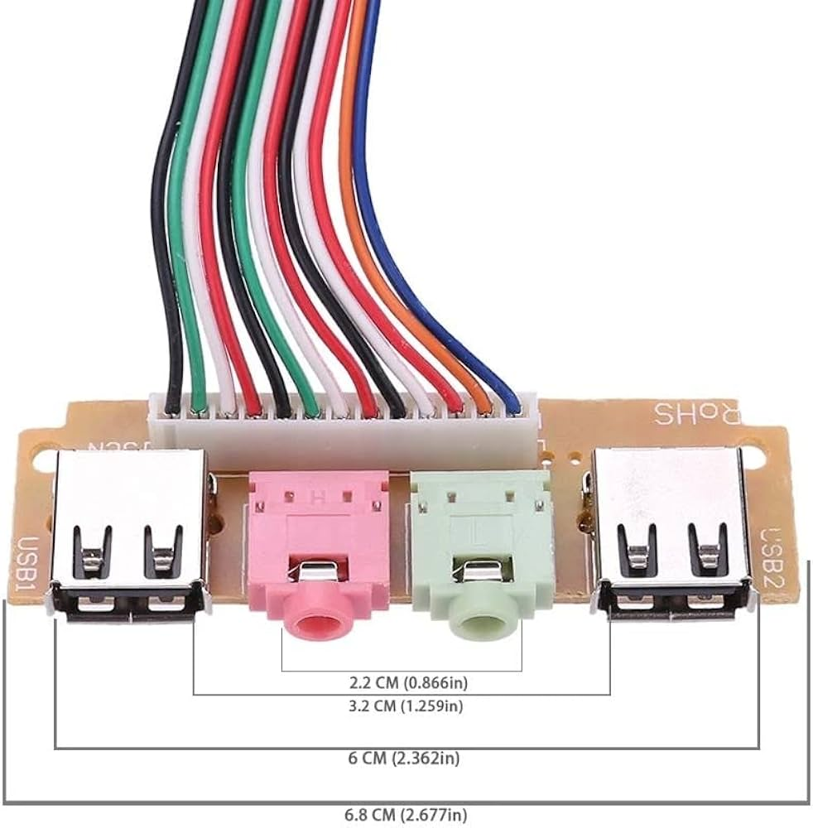
Color | Use
Green | Headphones
Pink | Microphone
Blue | Line-in
Also:
- Optical audio (S/PDIF)
- USB audio interfaces

🔌 Internal PC Cables (Inside Cabinet Reality)
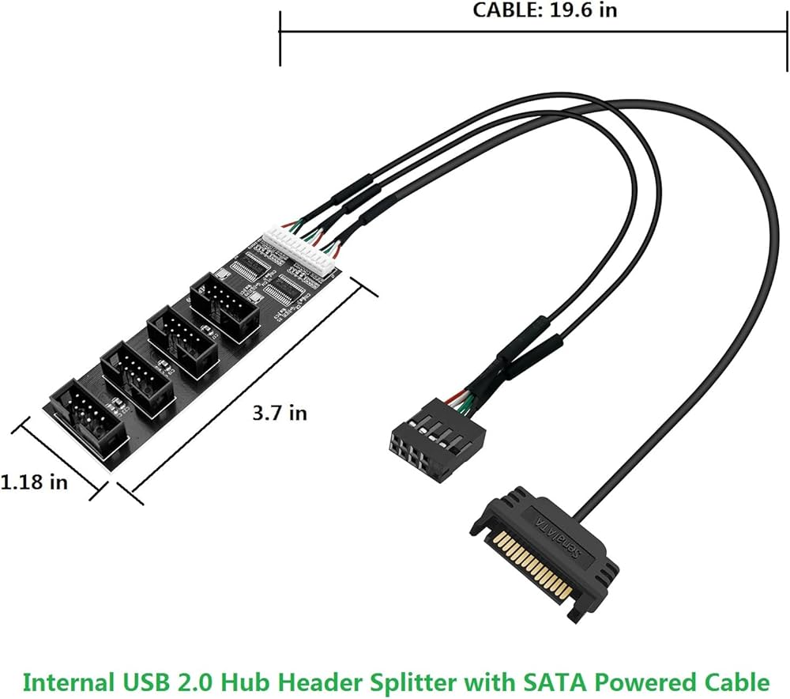
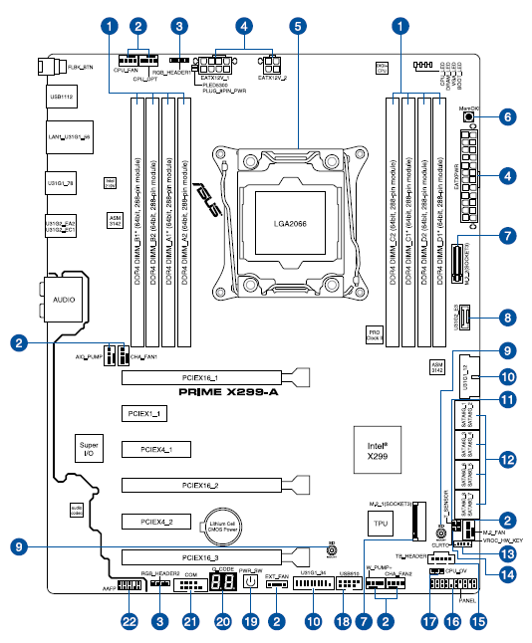

🔌 SATA Data vs SATA Power
SATA Data
- Thin cable
- Motherboard → SSD/HDD
SATA Power
- From PSU
- Powers storage devices
❌ Not interchangeable

🔲 Front Panel Connectors
Tiny cables from PC case:
- Power button
- Reset button
- Power LED
- HDD LED
📌 Polarity matters for LEDs.

❄️ Fan Headers
Header | Use
CPU_FAN | CPU cooler
SYS_FAN | Case fans
PUMP | Liquid cooling
⚠️ Wrong header → boot warning or overheating.

🌈 RGB vs ARGB (Common Mistake)
Type | Voltage | Pins
RGB | 12V | 4-pin
ARGB | 5V | 3-pin
❌ Plugging ARGB into RGB header = burn LEDs
ARGB = addressable (individual LED control)

🧠 Monitor + Cable + GPU Rule
All three must support:
- Resolution
- Refresh rate
- Color depth
Weakest link limits performance.

🏁 Final One-Line Truths
- Cable choice matters
- USB-C ≠ Thunderbolt
- HDMI ≠ DisplayPort
- ARGB ≠ RGB
- Ports define capability, not looks

